**Title**

Design a full-fledged network for an organization with multiple subnets.

**Requirements**

• PCs

• Wireless End Devices

• Switches (Model 2960)

• Routers • Wireless Routers (Linksys-WRT300N)

• DNS Server

• Web Server

• DHCP Server

• Copper Straight-Through Cable

• Copper Cross-Over Cable

• Serial DCE Cable

**Design**

|  |  |  |  |
| --- | --- | --- | --- |
| **Campuses** | **Network Class** | **Subnet Mask** | **Wildcard** |
| Campus 1 | Class A (91.0.0.0/18) | 255.255.192.0 | 0.0.63.255 |
| Campus 2 | Class A (92.0.0.0/18) | 255.255.192.0 | 0.0.63.255 |
| Campus 3 | Class B (133.0.0.0/22) | 255.255.252.0 | 0.0.3.255 |
| Campus 4 | Class B (134.0.0.0/22) | 255.255.252.0 | 0.0.3.255 |
| Campus 5 | Class C (205.0.0.0) | 255.255.255.0 | 0.0.0.255 |

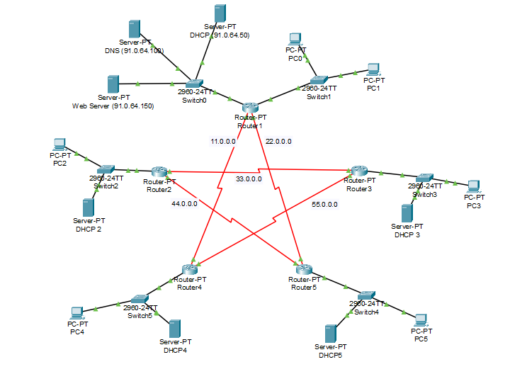

**Figure 1: Diagram of the network**

**Router 1 (Campus 1)**

interface fa0/0

ip address 91.0.64.1 255.255.192.0

no shut

do wr

exit

interface fa1/0

ip address 91.0.128.1 255.255.192.0

no shut

do wr

exit

interface se2/0

ip address 11.0.0.11 255.255.255.0

clock rate 64000

no shut

do wr

exit

interface se3/0

ip address 22.0.0.22 255.255.255.0

clock rate 64000

no shut

do wr

exit

**Router 2 (Campus 2)**

interface fa0/0

ip address 92.0.64.1 255.255.192.0

no shut

do wr

exit

interface fa1/0

ip address 92.0.128.1 255.255.192.0

no shut

do wr

exit

interface se2/0

ip address 33.0.0.33 255.255.255.0

clock rate 64000

no shut

do wr

exit

interface se3/0

ip address 44.0.0.44 255.255.255.0

clock rate 64000

no shut

do wr

exit

**Router 3 (Campus 3)**

interface fa0/0

ip address 133.0.0.1 255.255.252.0

no shut

do wr

exit

interface se2/0

ip address 33.0.0.34 255.255.252.0

clock rate 64000

no shut

do wr

exit

interface se3/0

ip address 55.0.0.55 255.255.255.0

no shut

do wr

exit

**Router 4 (Campus 4)**

interface fa0/0

ip address 134.0.0.1 255.255.252.0

no shut

do wr

exit

interface se2/0

ip address 11.0.0.12 255.255.252.0

no shut

do wr

exit

interface se3/0

ip address 55.0.0.56 255.255.255.0

no shut

do wr

exit

**Router 5 (Campus 5)**

interface fa0/0

ip address 205.0.0.1 255.255.255.0

no shut

do wr

exit

interface se2/0

ip address 22.0.0.23 255.255.252.0

no shut

do wr

exit

interface se3/0

ip address 44.0.0.45 255.255.255.0

no shut

do wr

exit

Codes for Routing Table:

**Router 1**

router ospf 1

network 91.0.0.0 0.0.63.255 area 1

network 11.0.0.0 0.0.0.255 area 1

network 22.0.0.0 0.0.0.255 area 1

exit

**Router 2**

router ospf 1

network 92.0.0.0 0.0.63.255 area 1

network 33.0.0.0 0.0.0.255 area 1

network 44.0.0.0 0.0.0.255 area 1

exit

**Router 3**

router ospf 1

network 133.0.0.0 0.0.3.255 area 1

network 33.0.0.0 0.0.0.255 area 1

network 55.0.0.0 0.0.0.255 area 1

exit

**Router 4**

router ospf 1

network 134.0.0.0 0.0.3.255 area 1

network 11.0.0.0 0.0.0.255 area 1

network 55.0.0.0 0.0.0.255 area 1

exit

**Router 5**

router ospf 1

network 205.0.0.0 0.0.0.255 area 1

network 22.0.0.0 0.0.0.255 area 1

network 44.0.0.0 0.0.0.255 area 1

exit